Police Enhanced Feature Set Control Function – CGEA 1.3/1.2

Functional Description

The Police Enhanced Feature Set (PEFS) is a suite of features specifically designed for the police fleet customer. Key attributes of the Police Enhance Feature Set include:
- The Fleet Manager can order the vehicle with a factory configuration that allows each individual feature to be customized using a service tool.
- The configuration method allows the vehicle program to charge for the enhanced feature set (i.e. a service tool cannot be used to enable the Enhanced Configuration).
- Any Ford Authorized Service Center or Police Fleet Service center can be used to customize each feature enabled by the factory configuration.
- The feature set can be easily expanded using existing configuration methods.

The specific feature that the Instrument Cluster controls is the Police Enhanced Speed Limiting feature. The Instrument Cluster stores the setting for the Police Enhanced Speed Limiting feature. The CAN signal used for MyKey speed limiting is re-used, since MyKey and Police are mutually exclusive.

For Police Enhanced Speed Limiting, a service tool can be used to set a maximum speed to one of twelve predetermined values:
- OFF, 90, 95, 100, 105, 110, 115, 120, 125, 130, 135 or 140 mph
There are no km/h choices.
There are 2 DID DExx parameters involved, since the enabling of the feature is restricted to VOPS (B&A) only. Once the VOPS bit is enabled, then the parameter for speed limiting is meaningful for service tools.

Interfaces

Interface Context Diagram (I/O Block Diagram)
Figure 1 Police Enhanced Features Context Diagram
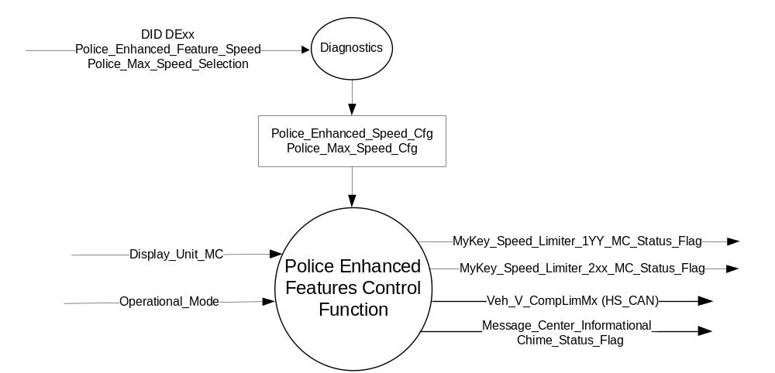

Inputs
      - INTERNAL:
            - Display_Unit_MC
            - Operational_Mode
            - Police_Enhanced_Speed_Cfg
            - Police_Max_Speed_Cfg

Outputs
- MyKey_Speed_Limiter_1YY_MC_Status_Flag that is used to control the Warning displayed in the message center.
- MyKey_Speed_Limiter_2xx_MC_Status_Flag that is used to control the Warning displayed in the message center.
- Message_Center_Informational_Chime_Status_Flag
- MUX messages on the HSCAN bus

- Veh_V_CompLimMx Signal
Signal Name | Size (bits) | Detail | Units | Res. | Offset | State Encoded | Min | Max
Veh_V_CompLimMx | 12 |  | Km/h | 0.1 | 0 |  | 0 (0x0) | 409.5 (0xFFF)

Function/Performance

Operational Modes

Mode | Differentiating Vehicle Conditions
Sleep Mode | OFF
Limited Mode | CAN signal Police Enhanced Features ON/OFF
Normal Mode | CAN signal Police Enhanced Features ON/OFF
Crank Mode | CAN signal Police Enhanced Features ON/OFF
Note: CAN signal transmitted anytime bus is awake

Voltage Levels

Refer to the Cluster Features Table located in the Operational Modes and Voltage Range Strategies Section of this SPSS.

Human-Machine Interface

Visual

1.3.3.1.1 Indicator Graphics / Display Format
Refer to HMI menu structure, translation tables, and graphic documents

1.3.3.1.2 Indicator Color Coordinates

Reference section COLOR & ILLUMINATION REQUIREMENTS (GRAPHICS).

1.3.3.1.3 Indicator Characteristics

None

Audio

W863 and W865 are associated with the Message_Center_Informational_Chime_Status_Flag.
Refer to Table 1.4

Switch Control Logic

None

System Accuracy

- The state of the CAN signal shall change within 100 msec of a state change as indicated in the state matrix found in section 1.3.5.1 of this document

Operation: Performance and Functional

Subsystem Algorithm Flowchart / State Diagram

Figure 2 – Police Enhanced Feature Speed and Police Max Speed Config

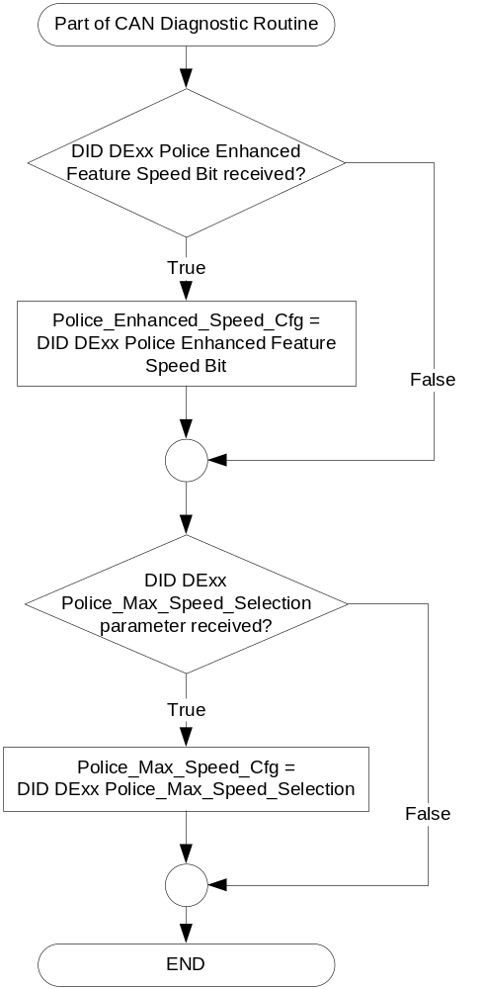

- Truth Table for Veh_V_CompLimMx Signal
Police_Enhanced_  Speed_Cfg | Police_Max_Speed_Cfg | (HS_CAN)  Veh_V_CompLimMx
True | (0x0) – Disabled | 409.5 (0xFFF)
True | (0x1) – unused | 409.5 (0xFFF)
True | (0x2) – unused | 409.5 (0xFFF)
True | (0x3) – unused | 409.5 (0xFFF)
True | (0x4) – unused | 409.5 (0xFFF)
True | (0x5) – 90 mph / 145 km/h | 144.9 (0x5A9)
True | (0x6) – 95 mph / 153 km/h | 152.9 (0x5F9)
True | (0x7) – 100 mph / 161 km/h | 161.0 (0x64A)
True | (0x8) – 105 mph / 169 km/h | 169.0 (0x69A)
True | (0x9) – 110 mph / 177 km/h | 177.1 (0x6EB)
True | (0xA) – 115 mph / 185 km/h | 185.1 (0x73B)
True | (0xB) – 120 mph / 193 km/h | 193.2 (0x78C)
True | (0xC) – 125 mph / 201 km/h | 201.2 (0x7DC)
True | (0xD) – 130 mph / 209 km/h | 209.3 (0x82D)
True | (0xE) – 135 mph / 217 km/h | 217.3 (0x87D)
True | (0xF) – 140 mph / 225 km/h | 225.4 (0x8CE)
False | N/A | See MyKey Gen II Control Function STSS  (Not applicable to Police Enhanced Feature)

- The MyKey feature is mutually exclusive with Police Features. This will be enforced by the VSCS. However, to protect for a mis-configuration, Police has priority. The cluster shall arbitrate any conflict internally as shown in the Table below.

- Truth Table for DID DExx Police_Enhanced_Speed_Cfg
Police_Enhanced_  Speed_Cfg | DID DExx MyKey_Feature_Supported
Enabled (0x1) | Disabled (0x0)*
Disabled (0x0) | Use Stored Value

*Note: The software handles this internally. The cluster does not have to physically change the value of MyKey_Feature_Supported. This is to avoid conflicts with output Veh_V_CompLimMx.

- Truth Table for MyKey_Speed_Limiter_1YY_MC_Status_Flag & MyKey_Speed_Limiter_2xx_MC_Status_Flag
Operational  _Mode | Police_  Enhanced_  Speed_Cfg | Display_  Units_  MC | Police_Max_Speed_Cfg | MyKey_  Speed_Limiter_  1YY_MC_  Status_Flag  & YYY | MyKey_  Speed_Limiter_  1xx_MC_  Status_Flag  & yyy
Normal | True | X | (0x0) – Disabled | Inactive & 0 | Inactive & 0
Normal | True | X | (0x1) – unused | Inactive & 0 | Inactive & 0
Normal | True | X | (0x2) – unused | Inactive & 0 | Inactive & 0
Normal | True | X | (0x3) – unused | Inactive & 0 | Inactive & 0
Normal | True | X | (0x4) – unused | Inactive & 0 | Inactive & 0
Normal | True | English  (0x0 OR 0x1) | (0x5) – 90 mph / 145 km/h | Active & 90 | Inactive & 0
Normal | True | English  (0x0 OR 0x1) | (0x6) – 95 mph / 153 km/h | Active & 95 | Inactive & 0
Normal | True | English  (0x0 OR 0x1) | (0x7) – 100 mph / 161 km/h | Active & 100 | Inactive & 0
Normal | True | English  (0x0 OR 0x1) | (0x8) – 105 mph / 169 km/h | Active & 105 | Inactive & 0
Normal | True | English  (0x0 OR 0x1) | (0x9) – 110 mph / 177 km/h | Active & 110 | Inactive & 0
Normal | True | English  (0x0 OR 0x1) | (0xA) – 115 mph / 185 km/h | Active & 115 | Inactive & 0
Normal | True | English  (0x0 OR 0x1) | (0xB) – 120 mph / 193 km/h | Active & 120 | Inactive & 0
Normal | True | English  (0x0 OR 0x1) | (0xC) – 125 mph / 201 km/h | Active & 125 | Inactive & 0
Normal | True | English  (0x0 OR 0x1) | (0xD) – 130 mph / 209 km/h | Active & 130 | Inactive & 0
Normal | True | English  (0x0 OR 0x1) | (0xE) – 135 mph / 217 km/h | Active & 135 | Inactive & 0
Normal | True | English  (0x0 OR 0x1) | (0xF) – 140 mph / 225 km/h | Active & 140 | Inactive & 0
Normal | True | Metric  (0x2 OR  0x3) | (0x5) – 90 mph / 145 km/h | Inactive & 0 | Active & 145
Normal | True | Metric  (0x2 OR  0x3) | (0x6) – 95 mph / 153 km/h | Inactive & 0 | Active & 153
Normal | True | Metric  (0x2 OR  0x3) | (0x7) – 100 mph / 161 km/h | Inactive & 0 | Active & 161
Normal | True | Metric  (0x2 OR  0x3) | (0x8) – 105 mph / 169 km/h | Inactive & 0 | Active & 169
Normal | True | Metric  (0x2 OR  0x3) | (0x9) – 110 mph / 177 km/h | Inactive & 0 | Active & 177
Normal | True | Metric  (0x2 OR  0x3) | (0xA) – 115 mph / 185 km/h | Inactive & 0 | Active & 185
Normal | True | Metric  (0x2 OR  0x3) | (0xB) – 120 mph / 193 km/h | Inactive & 0 | Active & 193
Normal | True | Metric  (0x2 OR  0x3) | (0xC) – 125 mph / 201 km/h | Inactive & 0 | Active & 201
Normal | True | Metric  (0x2 OR  0x3) | (0xD) – 130 mph / 209 km/h | Inactive & 0 | Active & 209
Normal | True | Metric  (0x2 OR  0x3) | (0xE) – 135 mph / 217 km/h | Inactive & 0 | Active & 217
Normal | True | Metric  (0x2 OR  0x3) | (0xF) – 140 mph / 225 km/h | Inactive & 0 | Active & 225
All other cases |  |  |  | Inactive & 0 | Inactive & 0

X = Don’t Care

YYY is used in definition of W863

yyy is used in definition of W865

- MyKey Vehicle Speed Limiter MC Status Flags to MC Warning Message ID
MC_Status_Flag | Mc Warning – Message ID | Active Chime_Status_Flag
MyKey_Speed_Limiter_1YY_MC_Status_Flag | W863 | Message_Center_Informational_  Chime_Status_Flag
MyKey_Speed_Limiter_2xx_MC_Status_Flag | W865 | Message_Center_Informational_  Chime_Status_Flag

Operation Description (supports algorithm flowchart /state diagram)

- The Police Features are mutually exclusive with the MyKey feature. In the event of a mis-configuration, the cluster shall internally give priority to Police Features.
- For definition of how the Message Center arbitrates and displays Active warnings, see the Warning / Alert Display Logic Diagram, located in the Message Center – X Display with W Button Interface section of this SPSS (where X and W are appropriate values in this document).

Function Safety Classification (EMC)
Class B

Memory Storage

Parameter Name | Description | Value at  Battery Connect | Value at Module Wake-up
Police_Enhanced_Speed_Cfg | Indicates if the vehicle has been ordered with the Police Enhanced Speed Feature. This parameter is to be stored in EEPROM. Parameter controlled via CAN at EOL at VO plant. DEFAULT VALUE FROM CLUSTER SUPPLIER IS DISABLED. | Use Stored Value | Use Stored Value
Police_Max_Speed_Cfg | This parameter can be changed in the field via a service tool per the customer’s request. This parameter is to be stored in EEPROM. Parameter controlled via CAN at EOL at VO plant. DEFAULT VALUE FROM CLUSTER SUPPLIER IS OFF | Use Stored Value | Use Stored Value
Veh_V_CompLimMx | This is the value transmitted in the CAN signal. The PCM will limit the vehicle to this maximum speed. | Use Stored Value | Do Not Init
MyKey_Speed_Limiter_1YY_MC_Status_Flag | Used to control the state of the warning to the Message Center arbitrator | INACTIVE (0x0) | INACTIVE (0x0)
MyKey_Speed_Limiter_2xx_MC_Status_Flag | Used to control the state of the warning to the Message Center arbitrator | INACTIVE (0x0) | INACTIVE (0x0)
Display_Units_MC | Parameter that controls display indicating units to the driver (i.e. English or Metric). | See Display Unit Control Function SPSS | See Display Unit Control Function SPSS
Operational_Mode | 4 state indicator for cluster operational mode | Limited | Limited or Normal or Crank
Message_Center_Informational_Chime_Status_Flag | Used to control the state of the chime to the Chime Arbitrator | Inactive | Inactive

Prove Out

No.

Reconfigurable Telltale

No.

Message Center Msg

Warning Message IDs W863 and W865 as defined in the Text Message List section of this SPSS.

Error Handling

Missing Message/Undefined Data Strategy

None.

Diagnostics

Self Test

None

Engineering Test Mode

Reference section “Dealer / Engineering Test Mode (ETM)”

Part II Performance
Supported Diagnostic PIDs (Service $22 and $2F)
Number | PID / CommonID Name | PID Type
None

Supported Diagnostic Trouble Codes (DTCs)
DTC | Description | When Logged
None

DID DExx
Block  Num | Block Description | Byte(s) | Bits | State: Description | "0" | "1" | Default | Comments/  Information
PACKETED BLOCKS
$XX* | Option Content (B&A) | * | * | Police_Enhanced_  Feature_Speed | Disabled | Enabled | Disabled | ** NOT DEALER CONFIG**  B&A ONLY
 |  | * | * | Police_Max_Speed_Selection | Encoded | Encoded | 0
 |  |  |  | 0x0 | Encoded | Encoded |  | 0x0 = OFF
 |  |  |  | 0x1 | Encoded | Encoded |  | 0x1 = unused
 |  |  |  | 0x2 | Encoded | Encoded |  | 0x2 = unused
 |  |  |  | 0x3 | Encoded | Encoded |  | 0x3 = unused
 |  |  |  | 0x4 | Encoded | Encoded |  | 0x4 = unused
 |  |  |  | 0x5 | Encoded | Encoded |  | 0x5 = 90 mph
 |  |  |  | 0x6 | Encoded | Encoded |  | 0x6 = 95 mph
 |  |  |  | 0x7 | Encoded | Encoded |  | 0x7 = 100 mph
 |  |  |  | 0x8 | Encoded | Encoded |  | 0x8 = 105 mph
 |  |  |  | 0x9 | Encoded | Encoded |  | 0x9 = 110 mph
 |  |  |  | 0xA | Encoded | Encoded |  | 0xA = 115 mph
 |  |  |  | 0xB | Encoded | Encoded |  | 0xB = 120 mph
 |  |  |  | 0xC | Encoded | Encoded |  | 0xC = 125 mph
 |  |  |  | 0xD | Encoded | Encoded |  | 0xD = 130 mph
 |  |  |  | 0xE | Encoded | Encoded |  | 0xE = 135 mph
 |  |  |  | 0xF | Encoded | Encoded |  | 0xF = 140 mph
*DExx Block number along with Byte and Bit location to be identified in Part II Specification for this cluster

Reference Specification

IS-0052 OPERATING VOLTAGES - FUNCTIONAL/PERFORMANCE
IS-0069 FUNCTIONAL IMPORTANCE CLASS

Revision History
SPSS Module Revision History

Revision Level | Name | Change Description | Date
1.0 | SWatkins | Initial Release. Feature owner is Tom Miller. | 10/22/2012
2.0 | T. Cwik | Update to add Speed Limited Greeting at Key ON.  Section 1.2.1 – Figure 1 – Added Display_Units_MC, MyKey_Speed_Limiter_1YY_MC_Status_Flag and MyKey_Speed_Limiter_2xx_MC_Status_Flag  Section 1.2.2 – Added Display_Units_MC  Section 1.2.3 – Added MyKey_Speed_Limiter_1YY_MC_Status_Flag and MyKey_Speed_Limiter_2xx_MC_Status_Flag  Section 1.3.3.1.1 – Rewrote  Section 1.3.3.1.2 – Rewrote  Section 1.3.3.2 – Rewrote  Section 1.3.5.1 – Added Tables 1.3 and 1.4  Section 1.3.5.2 – Added 2nd tic point  Section 1.3.5.4 – Added Display_Units_MC, MyKey_Speed_Limiter_1YY_MC_Status_Flag and MyKey_Speed_Limiter_2xx_MC_Status_Flag  Section 1.3.5.7 -- Rewrote | 12/3/2012
2.1 | Ilopezla | This Update is to inform which Chime Status Flags are associated with this warning as per Global_Msg_List_ver32_Released_6_24_2015  Section 1.2.1- Figure 1 -Added Message_Center_Informational_Chime_Status_Flag  Section 1.2.3- Added Message_Center_Informational_Chime_Status_Flag  Section 1.3.3.2- Added Message_Center_Informational_Chime_Status_Flag  Added Table 1.4 Reference Hyperlink  Section 1.3.5.1 - Updated Table 1.4  Changed column header from Chime to Active Chime_Status_Flag  Added Message_Center_Informational_Chime_Status_Flag  Section 1.3.5.4- Added Message_Center_Informational_Chime_Status_Flag row | 11/30/2016

